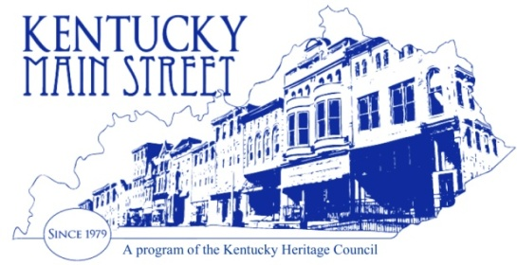
2018 Winter Conference: Transforming Your Downtown

Odd Fellows Building, 113 Bridge Street, Frankfort

Tuesday Jan 23

1:30-2:00 Who’s Who in Main Street – introduction of MS directors
Welcome by Kentucky State Historic Preservation Officer – Craig Potts
News to Know - Craig Potts

2:00 – 2:45 Aging in Place Jeff Rubin

2:45 – 3:00 Break

3:00 – 3:15 Troy Hearn- bikes, bikes, bikes, get a plan!

3:15 – 3:30 Ashley Wesley – Ice rinks and more

3:30 – 4:00 Main Street updates News for 2018 Kitty Dougoud

4:00 – 5:00 Friends - 40th Anniversary – Fall Conference - Wrap up, Q &A etc.

8:00 -9:00 UK game, come enjoy fellowship and fun and cheer on the CATS.

Wed. Jan 24

9:00 – 2:15 Day at the Capitol
You will be allowed to begin setting up in the capitol at 8:30 am. Make your appointment to meet with your legislator during the time you are there. It’s always a great time to see them in Frankfort and take them a treat

Dinner on your own (there are several places to eat within walking distance of the hotel)

Thursday Jan 25th

8:30 – 4:00 Main Street Transformation Strategies Development and Implementation
Michigan Main Street Coordinator, Laura Krizov & Leigh Young Main Street Specialist, MEDC - Community Dev. & Marketing

10:00-10:15 BREAK

12:00-1:00 Lunch on your own

4:00 - 4:30 Final thoughts and announcements /evaluations etc.

