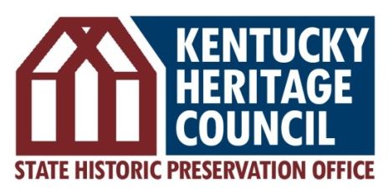
The Barstow House
410 High Street
Frankfort, KY 40601
502-564-7005
www.heritage.ky.gov

About State Historic Preservation Offices
The Kentucky Heritage Council (KHC) serves as the State Historic Preservation Office (SHPO), a key component of implementing the national historic preservation program at the state and local levels. Federal funding to SHPO offices is provided through the Historic Preservation Fund (HPF), which is used to recognize, save, and protect historic places. The HPF does not use taxpayer dollars, but is generated by a small portion of royalties that energy companies pay for the right to drill on the federally owned Outer Continental Shelf (OCS). States are required to match the federal allocation at a minimum of 40%, and together these funds create a federal-state-local partnership to preserve the places that tell America’s story and support local entities with the resources they need to enable both public and private preservation efforts.
The Kentucky Heritage Council makes it a priority to streamline
the federal process to enhance the delivery of projects for the U.S. Army Corps of Engineers, Kentucky Transportation Cabinet, and companies seeking to invest in our state

Our work supports infrastructure development

Our agency is not funded by federal taxpayer dollars

Our service to the Commonwealth is a testament to our small staff

We deliver so investment can be made throughout the Commonwealth!

Kentucky Heritage Council staff review more than
$1 BILLION worth
of investment in projects across the state EACH YEAR

Historic Rehabilitation Tax Credits
KHC administers both state and federal historic rehabilitation tax credit programs. In 2018, Kentucky ranked 13th nationally utilizing the Federal Historic Rehabilitation Tax Credit, with 27 successfully completed projects generating investment of $56,891,561. This tax credit can often be utilized in tandem with the Kentucky Historic Preservation Tax Credit, a key provision that strengthens use and effectiveness of both programs.

In 2018, KHC received 115 applications for the Kentucky preservation tax credit from 20 counties; 111 of these were approved pending completion of the work. These approved projects represent $106,128,944 in proposed private investment in rehabilitation. Since implemented in 2005, through 2018, the state tax credit has resulted in:

- 891 buildings rehabilitated across Kentucky
- $517 million of private funds invested in historic buildings, leveraged through $39.7 million in credits
- 17,475 jobs created

Kentucky Main Street Program
The Kentucky Main Street Program is also administered by KHC and supports preservation and reuse of architecturally and historically significant buildings by providing structure for a community-driven approach, encouraging and benefiting independently-owned small businesses.

In 2018, 29 participating programs cumulatively reported $75,976,856 of investment in downtown commercial districts, representing $59,418,221 of private investment matched by $16,558,635 in public improvements. Statewide, the program also generated 1,078 new jobs in Main Street districts, with 130 new businesses created, 375,546 volunteer hours invested, and 125 rehabilitation projects completed.

Since the program’s inception in 1979, Kentucky Main Street can document more than $4.5 billion of public-private investment throughout the state!

